Question4
- Create a rule that automatically assign a bug to a developer when the priority set to highest
Ans) Rule to Automatically Assign Bug (When Priority = Highest)
This is typically done using automation rules (e.g., in Jira).
Rule Logic
Trigger:
- Issue Created OR Issue Updated
Condition:
- Issue Type = Bug
- Priority = Highest
Action:
- Assign issue to specific developer

Example (Step-by-Step)
- Go to Project Settings → Automation
- Click Create Rule
Configure:
Trigger
Issue Created OR Issue Updated
Condition
Issue Type = Bug
AND Priority = Highest
Action
Assign Issue → Developer Name (e.g., John)
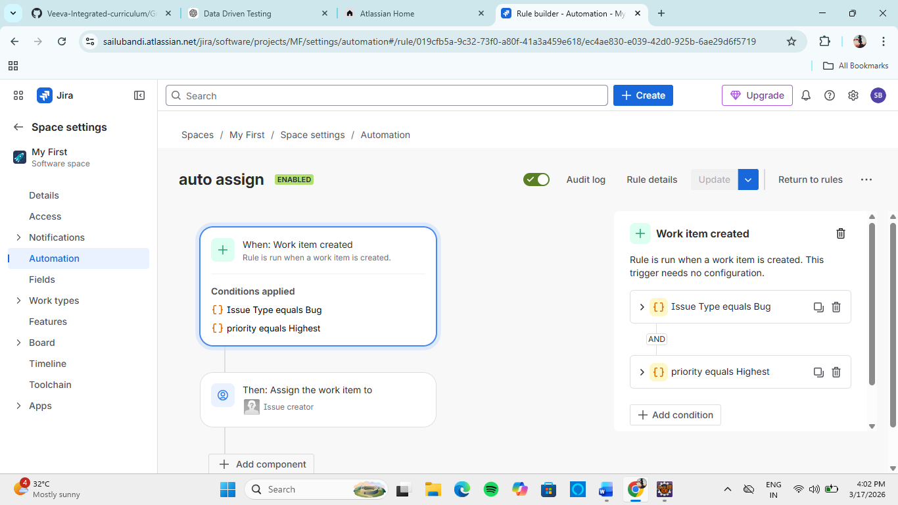

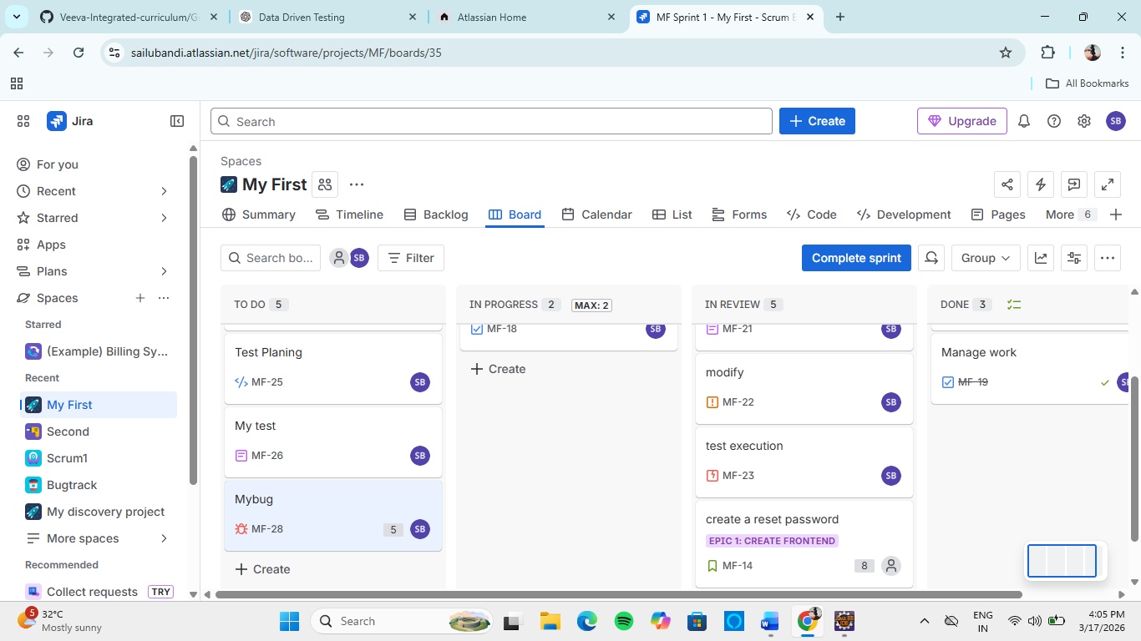

- Write a query to find all unresolved bugs in a specific project assign to a specific user . Example->project=P1 and issuetype=bug and status!=done and assignee=current user

project = P1 AND issuetype = Bug AND status != Done AND assignee = currentUser()

Explanation
- project = P1 → specific project
- issuetype = Bug → only bugs
- status != Done → unresolved issues
- assignee = currentUser() → assigned to logged-in user

